ECA5802-IOE AND AI DRIVEN SYSTEMS

EXPERIMENT NO 1:
SIMULATION AND COMPARATIVE PERFORMANCE EVALUATION OF ZIGBEE,6LOWPAN AND NB-IOT COMMUNICATION PROTOCOLS FOR IOE APPLICATIONS.

OBJECTIVES:
1. To simulate Zigbee, 6LoWPAN, and NB-IoT communication protocols for IoE applications.
2. To evaluate the performance of these protocols based on latency, throughput, energy consumption, and reliability.
3. To compare the simulation results and identify the most suitable communication protocol for different IoE applications.

PROGRAM CODE:
import numpy as np
import matplotlib.pyplot as plt
from scipy.special import erfc
distance = np.linspace(10, 1000, 100)
# =====================================================
# Common BER equation
# BER = 0.5 * erfc(sqrt(SNR))
# =====================================================
# =====================================================
# 1. ZIGBEE
# =====================================================
Pt = 0 # Transmit power (dBm)
PL0 = 40 # Path loss at 1 m (dB)
n = 3.0 # Path loss exponent
N = -140 # Noise power (dBm)
PL = PL0 + 10*n*np.log10(distance)
Pr = Pt - PL
SNR = Pr - N
BER = 0.5 * erfc(np.sqrt(10**(SNR/10)))
plt.figure(figsize=(7,5))
plt.semilogy(distance, BER)
plt.xlabel("Distance (m)")
plt.ylabel("Bit Error Rate (BER)")
plt.title("Zigbee: BER vs Distance")
plt.grid(True)
plt.show()
# =====================================================
# 2. 6LoWPAN
# =====================================================
Pt = 0
PL0 = 40
n = 3.0
N = -140
PL = PL0 + 10*n*np.log10(distance)
Pr = Pt - PL
SNR = Pr - N
BER = 0.5 * erfc(np.sqrt(10**(SNR/10)))
plt.figure(figsize=(7,5))
plt.semilogy(distance, BER)
plt.xlabel("Distance (m)")
plt.ylabel("Bit Error Rate (BER)")
plt.title("6LoWPAN: BER vs Distance")
plt.grid(True)
plt.show()
# =====================================================
# 3. NB-IoT
# =====================================================
Pt = 23
PL0 = 31
n = 3.5
N = -140
PL = PL0 + 10*n*np.log10(distance)
Pr = Pt - PL
SNR = Pr - N
BER = 0.5 * erfc(np.sqrt(10**(SNR/10)))
plt.figure(figsize=(7,5))
plt.semilogy(distance, BER)
plt.xlabel("Distance (m)")
plt.ylabel("Bit Error Rate (BER)")
plt.title("NB-IoT: BER vs Distance")
plt.grid(True)
plt.show()

OUTPUT GRAPH:
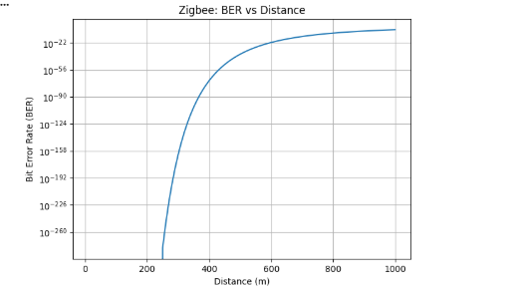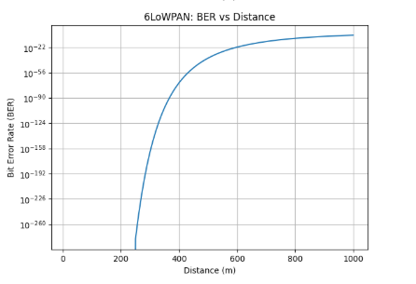
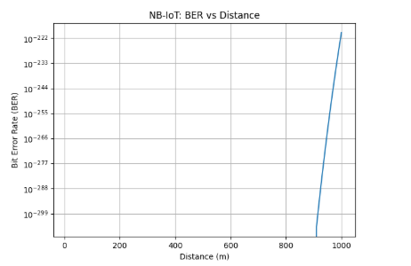
TABLE COLUMN:
Column 1 | Zigbee(10mm) | 6LOWPAN(20m) | NB-IOT

RESULT:
The Zigbee, 6LoWPAN, and NB-IoT communication protocols were simulated and their performance was compared based on latency, throughput, energy consumption, and reliability. The suitable protocol was identified based on the requirements of IoE applications

